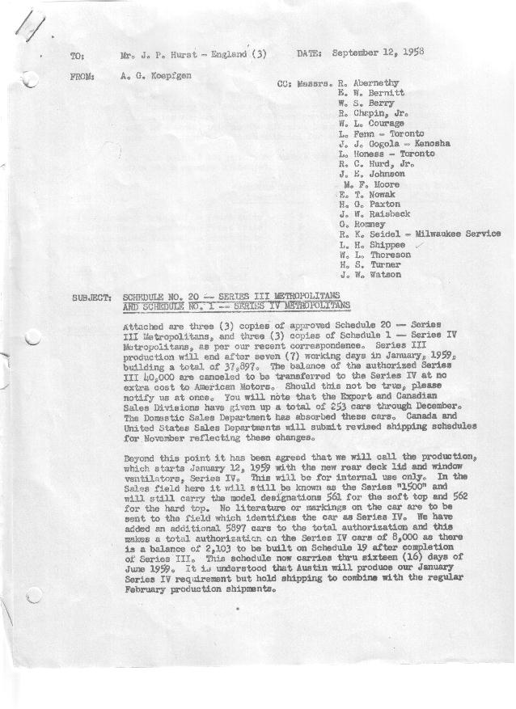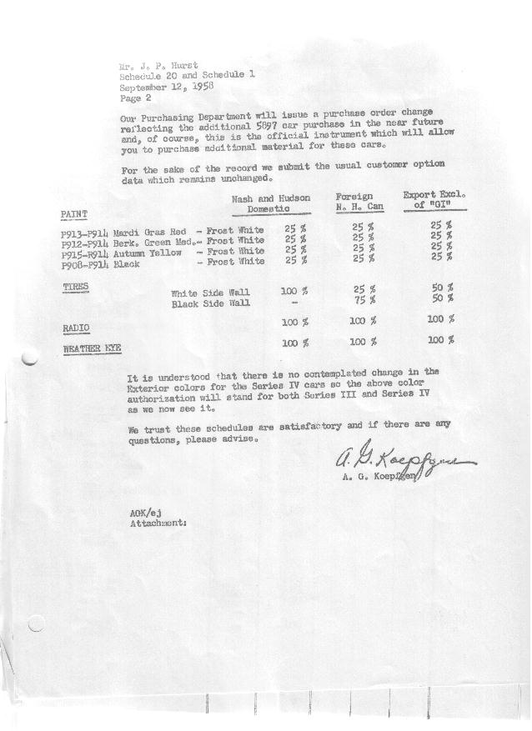

FORM AM 1262 APPROVED R. Abernethy (signed) DATE 9/16/58

SCHEDULE NO. ______20 ___ DATE 9-12-58 MONTHLY BUILDING SCHEDULE APPROVED R. W.Chapin Jr. (signed) DATE_ 9/16/58 _
REVISION NO. _______ ______ DATE PRODUCT APPROVED E.W.Bernitt (signed) DATE _ 9-16-58 ____
FINAL SERIES III 1500 c.c. ENGINE
METROPOLITAN SERIES CARS – AUSTIN MOTORS CO., LTD, ENGLAND
DESCRIPTION | BUILT  ◻ACT EST  THRU  AUGUST | FIRM BUILDING SCHEDULE  (FABRICATED MATERIAL RELEASE) |  |  |  |  |  |  |  |  |  |  |  |  |  |  | TENTATIVE SCHEDULE  (RAW MATERIAL RELEASED) |  |  | GRAND  TOTAL
DESCRIPTION | BUILT  ◻ACT EST  THRU  AUGUST | MONTH SEPTEMBER  DAYS 22 |  |  | MONTH OCTOBER  DAYS 23 |  |  | MONTH NOVEMBER  DAYS 20 |  |  | MONTH DECEMBER  DAYS 21 |  |  | MONTH JANUARY 1959  DAYS 7 |  |  | MONTH  DAYS |  |  | GRAND  TOTAL
DESCRIPTION | BUILT  ◻ACT EST  THRU  AUGUST | DAILY | MONTH | CUM’L  TOTAL | DAILY | MONTH | CUM’L  TOTAL | DAILY | MONTH | CUM’L  TOTAL | DAILY | MONTH | CUM’L  TOTAL | DAILY | MONTH | CUM’L  TOTAL | DAILY | MONTH | CUM’L TOTAL | GRAND  TOTAL
DOMESTIC LHD:
Hard-Top | 24653 |  | 1065 | 25718 |  | 1116 | 26834 |  | 937 | 27771 |  | 718 | 28489 |  | 241 | 28730
Soft-Top | 4151 |  | 78 | 4229 |  | 122 | 4351 |  | 111 | 4462 |  | 81 | 4543 |  | 39 | 4582
Total U.S. | 28804 | 60.0 | 1143 | 29947 | 53.8 | 1238 | 31185 | 52.4 | 1048 | 32233 | 38.0 | 799 | 33032 | 40.1 | 280 | 33312
Over/(Under) Schedule 19 | 41 |  | 39 | 80 |  | 67 | 147 |  | 398 | 545 |  | 42 | 587 |  | 32 | 619
FOREIGN:
EXPORT LHD Hard-Top | 789 |  | 27 | 816 |  | 20 | 836 |  | 20 | 856 |  | 20 | 876 |  | -0- | 876
Soft-Top | 367 |  | 19 | 386 |  | 10 | 396 |  | 10 | 406 |  | 10 | 416 |  | -0- | 416
Total Export LHD | 1156 |  | 46 | 1202 |  | 30 | 1232 |  | 30 | 1262 |  | 30 | 1292 |  | -0- | 1292
RHD Hard Top | 355 |  | 11 | 366 |  | 10 | 376 |  | 10 | 386 |  | 10 | 396 |  | -0- | 396
Soft Top | 60 |  | 6 | 66 |  | 3 | 69 |  | 3 | 72 |  | 3 | 75 |  | -0- | 75
Total Export RHD | 415 |  | 17 | 432 |  | 13 | 445 |  | 13 | 458 |  | 13 | 471 |  | -0- | 471
Total Export LHD & RHD | 1571 | 2.9 | 63 | 1634 | 1.9 | 43 | 1677 | 2.1 | 43 | 1720 | 2.1 | 43 | 1763 | 0.0 | -0- | 1763
Over/(Under) Schedule 19 | (70) |  | (12) | (82) |  | (22) | (104) |  | (32) | (136) |  | (22) | (158) |  | (24) | (182)
CANADA Hard-Top | 2435 |  | 75 | 2510 |  | 25 | 2535 |  | 45 | 2580 |  | -0- | 2580 |  | -0- | 2580
Soft-Top | 242 |  | -0- | 242 |  | -0- | 242 |  | -0- | 242 |  | -0- | 242 |  | -0- | 242
Total Canada | 2677 | 3.4 | 75 | 2752 | 1.1 | 25 | 2777 | 2.3 | 45 | 2822 | 0 | -0- | 2822 | 0.0 | -0- | 2822
Over/(Under) Schedule 19 | (3) |  | 5 | 2 |  | (45) | (43) |  | (32) | (75) |  | (20) | (95) |  | (8) | (103)
Total Foreign | 4248 | 6.3 | 138 | 4386 | 3.0 | 68 | 4454 | 4.4 | 88 | 4542 | 2.1 | 43 | 4585 | 0.0 | -0- | 4585
Over/(Under) Schedule 19 | (73) |  | (7) | (80) |  | (67) | (147) |  | (64) | (211) |  | (42) | (253) |  | (32) | (285)
GRAND TOTALS
Hard-Top | 28232 | 53.5 | 1178 | 29410 | 50.9 | 1171 | 30581 | 50.6 | 1012 | 31593 | 35.6 | 748 | 32341 | 34.5 | 241 | 32582
Soft-Top | 4820 | 4.7 | 103 | 4923 | 5.9 | 135 | 5058 | 6.2 | 124 | 5182 | 4.5 | 94 | 5276 | 5.6 | 39 | 5315
Total | 33052 | 58.2 | 1281 | 34333 | 56.8 | 1306 | 35639 | 56.8 | 1136 | 36775 | 40.1 | 842 | 37617 | 40.1 | 280 | 37897
Over/(Under) Schedule 19 | (32) |  | 32 | -0- |  | -0- | -0- |  | 334 | 334 |  | -0- | 334 |  | -0- | 334

